Chicken Voice Health Classification System

1. Project Overview
The Chicken Voice Health Classification System is an AI-based application designed to analyse chicken vocal sounds and classify them into different health categories. The system uses deep learning techniques and audio signal processing to detect whether a chicken is healthy, unhealthy, or if the uploaded audio contains noise.

2. Objectives
- Detect chicken health condition using voice recordings.
- Reduce manual health inspection workload
- Build a deployable AI system accessible via API and Web UI

3. Technologies Used
Programming Language
- Python
Machine Learning & Audio Processing
- PyTorch
- Librosa
- NumPy
Web & Deployment
- FastAPI (API Server)
- Streamlit (Frontend Interface)

4. System Architecture
Step 1: Data Collection
- Chicken audio recordings are collected
- Audio files are labelled as:
  - Healthy
  - Unhealthy
  - Noise
Step 2: Data Preprocessing
- Audio converted to fixed duration
- Sampling rate standardized
- Mel spectrogram generated
- Audio normalized
Step 3: Model Training
- Deep learning model (ResNet architecture) is trained
- Model learns audio patterns linked to chicken health
Step 4: Model Inference
- Uploaded audio is processed
- Model predicts health category
- Confidence scores generated
Step 5: Deployment
- API Server handles predictions
- Streamlit UI provides user interaction

5. Project Folder Structure
chick_voice/
│
├── api_server.py # FastAPI prediction server
├── app.py # Streamlit UI
├── dataset.py # Data preprocessing and loading
├── model.py # Deep learning model architecture
├── infer.py # Model testing and inference
├── train.py # Model training script
├── requirements.txt # Project dependencies
├── runtime.txt # Python version configuration
├── models/
│ └── chicken_resnet_best.pt

6. System Output and Result Visualization
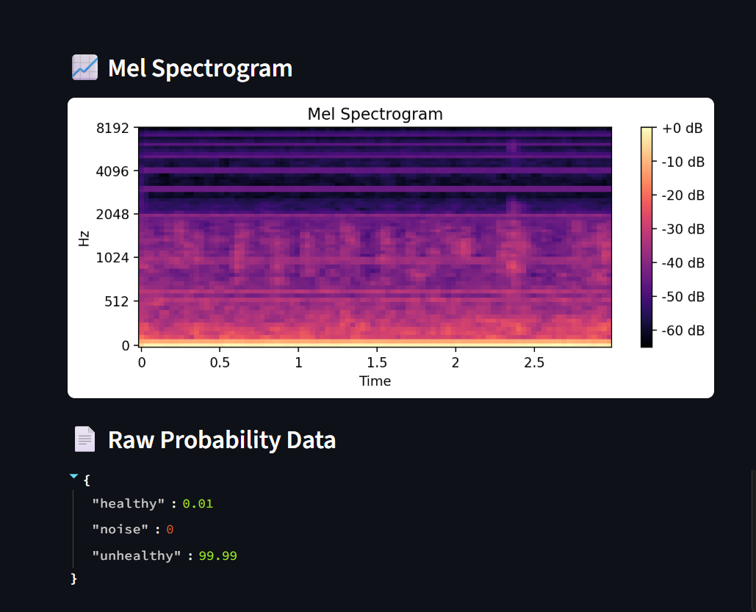

7. Installation Guide
Step 1: Clone Repository
git clone <repository_link>
cd chick_voice
Step 2: Create Virtual Environment
python -m venv venv
Step 3: Activate Environment
Windows:
venv\Scripts\activate
Linux/Mac:
source venv/bin/activate
Step 4: Install Dependencies
pip install -r requirements.txt

7. Training the Model
python train.py
The trained model will be saved in:
models/chicken_resnet_best.pt

8. Running the API Server
uvicorn api_server:app --host 0.0.0.0 --port 8000

9. Running Streamlit Interface
streamlit run app.py

10. API Usage
Endpoint
POST /predict
Input
- WAV audio file
Output
- Prediction Label
- Confidence Score

11. How New Developers Can Continue This Project
Step 1: Understand Audio Processing
- Learn Mel Spectrogram conversion
- Study audio normalization techniques
Step 2: Improve Dataset
- Collect more chicken sound samples
- Include different breeds and environments
Step 3: Improve Model
- Experiment with advanced architectures
- Try transfer learning
- Improve training dataset balance
Step 4: Improve UI
- Add real-time recording
- Add prediction history
- Add farmer-friendly dashboard.

12. Future Scope
- Real-time farm monitoring
- IoT integration with microphones
- Multi-disease classification
- Mobile application support
- Smart farm automation integration

13. Conclusion
This project demonstrates how AI and audio processing can help improve poultry health monitoring. With further improvements and larger datasets, this system can become a reliable solution for smart farming applications.

